Profile-Based Customized Emails for Mass Mailing

Table of Contents

1. Project Overview 1-3
2. Architecture & Design Patterns 4-4
3. Component Specifications 5-7
4. API Documentation 7-15
5. Data Flow & Workflows 16-20
6. Deployment Guide 20-24
7. Business Documentation 24-27
8. Technical Specifications 28-29
9. Troubleshooting 29-30
10. Advantages 30-30
11. Limitation 30-30
12. Future enhancement 30-30
13. Conclusion 31-31
14. Version History 31

1. Project Overview

1.1 Purpose
This project automates the generation and delivery of personalized marketing emails at scale. Traditional mass mailing sends generic content to large groups, resulting in low engagement. This system solves that problem using AI-driven personalization, prospect profiling, and automated campaign management.
By integrating Retrieval-Augmented Generation (RAG), and an LLM (Large Language Model), the system creates highly customized subject lines and email content for each prospect.

1.2 Objectives
- To automatically generate personalized email content using user profiles.
- To segment prospects based on their behavior and attributes.
- To optimize email, send-timing for higher engagement.
- To track email performance (open, click, bounce rates).
- To provide an automated mass mailing system with compliance support.
- To use AI/RAG to fetch context and enhance personalization.

1.3 Key Features

Feature | Description
Profile Analysis | Analyse user profiles, interests, and past engagement patterns.
Personalized Emails | Customize subject lines, content, and call-to-action based on persona.
Self learning | Send items are stored in database for optimizing the solution.
Promotion mails | No response
Actionable mails | Provide response in accordance with the type of mail

1.4 Technology Stack

- Backend Framework: FastAPI
- AI/ML: Azure OpenAI (GPT-4o, text-embedding-3-small)
- LLM Orchestration: LangChain
- Vector Database: Milvus/zilliz cloud
- Document Processing: Text
- Configuration: YAML, python-dotenv
- Logging: colorlog
- Python Version: 3.12

2. Architecture & Design Patterns

2.1 System Architecture
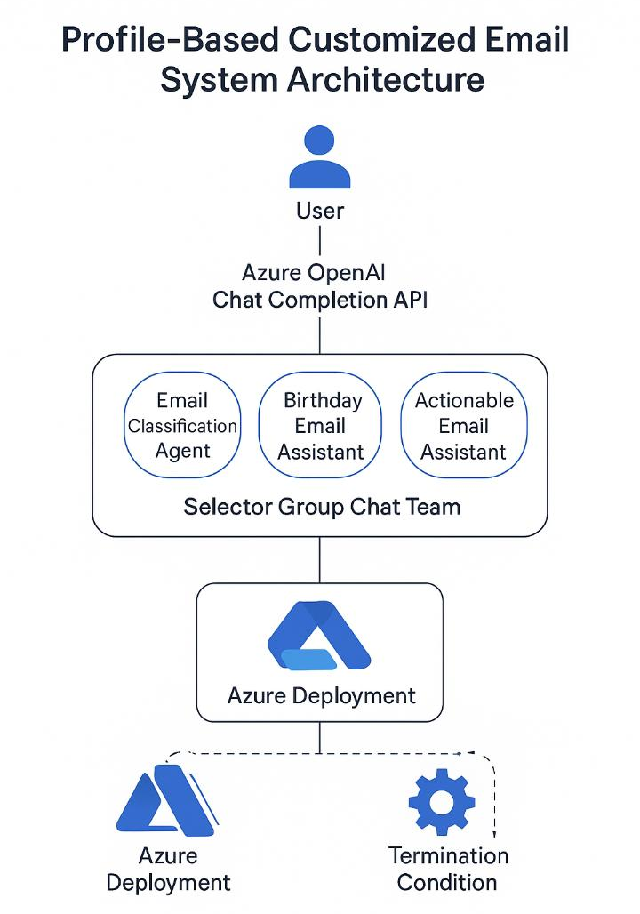

2.2 Design Patterns

- ConfigLoader: Global configuration instance (`get_config()`)
- Category Initialization: Agent
- Text Chunking: Multiple chunking strategies (recursive, character, token-based)
- Email Processing: Agent and tools used for categorizing, Route to category.
- Chat Agent: Uses tools and reasoning to answer queries

3. Component Specifications

3.1 Core Components

3.1.1 Profile Analyzer

Location | Purpose | Input | Output:
src/agent/profile_analyzer.py | Extracts structured insights from prospect details. | Name  Industry  Role and seniority  Behavioral patterns (website visits, email history)  Social media activity | Profile summary  Interest category  Engagement type  Recommended tone  Personalized CTA suggestions

Key Methods
- analyze_profile()
- extract_personalization_tokens()
- score_engagement()

3.1.2 Email Generator

Location | Purpose | Steps | Outputs
src/agent/email_generator.py | Generate personalized email content using GPT-4o | - Build prompt from profile + RAG data  - Generate subject line variations  - Generate body and CTA  - Score email quality | - subject_line  - email_body  - CTA  - tone  - personalization tokens

3.1.3 RAG Engine

Location | Purpose | Sources | Tools
src/agent/rag_engine.py | Fetch relevant knowledge for personalization. | - Company recent announcements  - Prospect’s social posts  - Industry newsletters  - Website browsing data  - Past emails sent to this user  - Engagement history | - WebCrawlerTool  - NewsletterRetriever  - CompanyNewsScraper  - MilvusVectorRetrieval

3.1.4 Engagement Tracker
Tracks:
- Email opens
- Link clicks
- CTA interactions
- Replies
- Unsubscribes
- Bounce details

Improves:
- Send-time optimization
- Tone selection
- Template ranking

3.1.5 Knowledge Base
Includes:
- Email templates
- Industry-specific messaging
- High-performing subject line library
- Personalization token rules
- Deliverability best practices

4. API Documentation

4.1 API Overview
Base URL : http://localhost:8000
API Documentation (Swagger): http://localhost:8000/docs
Alternative Documentation (ReDoc): http://localhost:8000/redoc
This API powers the backend for Profile-Based Customized Email Generation, enabling:
- Personalized email generation using LLM
- Profile enrichment using RAG
- Email scheduling
- CTA generation
- Persona-based tone adaptation
- Semantic search of stored emails via Milvus
- Chat-based assistant for campaign insights

4.2 API Endpoints

4.2.1 Health Check
GET/ health
Description: Check service health and availability.
Response Example:
{
"status": "healthy",
"version": "1.0.0",
"milvus_enabled": true,
"email_engine": "active"
}

Status Codes :
- 200 OK – Service available
## add screenshot and api

4.2.2 Generate Customized Email
POST/email/generate
Description: Generate a fully personalized email (subject + body + CTA) based on user profile.
Request Body
{
“profile_id:”P12345”,
“name”:”Priya Ambadakar”,
“occasion”:”Birthday”,
“tone”:”friendly”,
“additional_context”:”Works in HR,enjoy team activity”,
“store_in_db”:true
}
Parameter:
- profile_id - Required, identifies recipient
- occasion - Birthday | Work Anniversary | Festival | Asset Approval | Generic
- tone - formal | friendly | professional | casual
- additional_context - Optional extra personalization
- store_in_db - Boolean, default true
## add screenshot
Success Response
{
"success": true,
"email_id": "uuid-string",
"subject": "Warm Birthday Wishes, !",
"body": "Dear Priya, wishing you a wonderful year ahead...",
"cta": "Share your celebration moments with the team!",
"tone_used": "friendly",
"source_type": "PROFILE"
}
Error Codes
- 400 – Missing profile fields
- 500– LLM generation failure

4.2.3 Bulk Email Generation
POST /email/bulk-generate
Description:
Generate emails for multiple profiles at once.
Request Example
{
"profiles": [
{"profile_id": "P101", "occasion": "Birthday"},
{"profile_id": "P102", "occasion": "Work Anniversary"}
],
"tone": "professional",
"store_in_db": true
}
Response
{
"success": true,
"generated_emails": 2,
"failed": 0
}

4.2.4 Analyze Uploaded Email Template / Uploaded Data File
POST /analyze/file
Description:
Upload document (Text) containing user profiles or email templates.
Use Cases
- Extract profile attributes
- Extract phrases to build tone/style library
- Build “brand voice” RAG knowledge base
Response:
Same structure as /email/generate with source_type: "FILE".

4.2.5 Chat With AI Email Assistant
POST /chat
Description:
Ask questions about:
- Generated emails
- Personalization rules
- Profile insights
- Best sending time
- CTA suggestions
- Email campaign insights

Request Body:
{
"message": "What CTA should I use for work anniversary mails?",
"session_id": "optional-session-id"
}
Response
{
"success": true,
"answer": "For work anniversary, a great CTA is: ‘Share your journey milestone with us!’",
"relevant_documents": 2,
"session_id": "session-uuid"
}

4.2.6 Search Profiles or Emails
POST /search
Description:
Semantic search across:
- Past generated emails
- User profiles
- Tone/style data
- CTA library

Request:
{
"query": "Birthday emails for HR department",
"top_k": 5
}
Response:
{
"success": true,
"query": "Birthday emails for HR department",
"results": [
{
"email_id": "uuid1",
"email_text": "Dear Priya, wishing you...",
"similarity_score": 0.92
}

4.2.7 CTA Generator
POST /cta/generate
Description:
Generate context-aware Call-To-Action.
Response:
{
"cta": "Share your celebration moments with the team!",
"confidence": "High"
}

4.2.8 Web Interface
GET /
Description:
Loads 3-panel UI:
- Left: Profile input / file upload
- Middle: Generated email results
- Right: Chat assistant

4.3 Schemas
Updated according to your project:
Profile Schema
{
"profile_id": "string",
"name": "string",
"department": "string",
"email": "string",
"occasion": "string",
"interests": "string",
"tone_preference": "string"
}
Generated Email Schema
{
"email_id": "string",
"subject": "string",
"body": "string",
"cta": "string",
"tone_used": "string",
"source_type": "PROFILE"
}
Error Schema
{
"detail": "Error message"
}

- Data Flow & Workflows

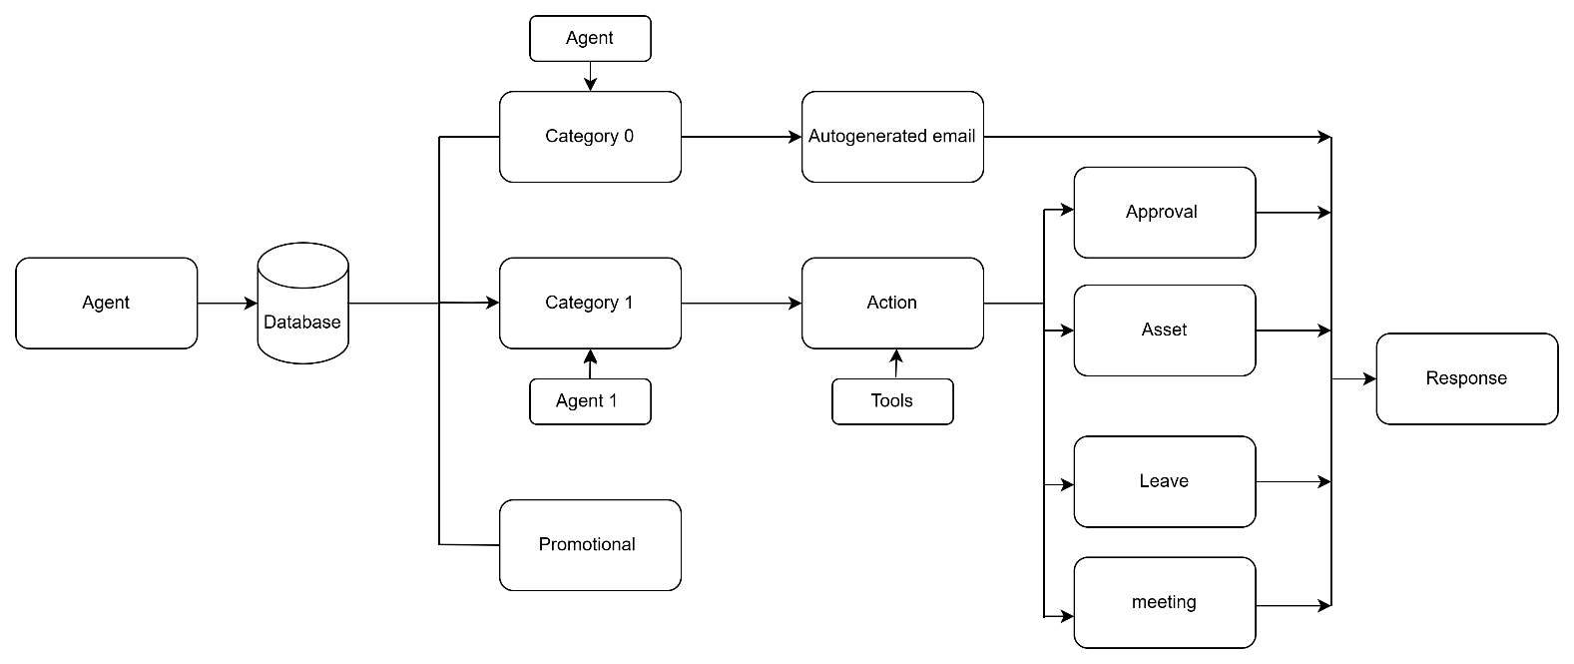

5.1 Profile -Based Email Generation workflow

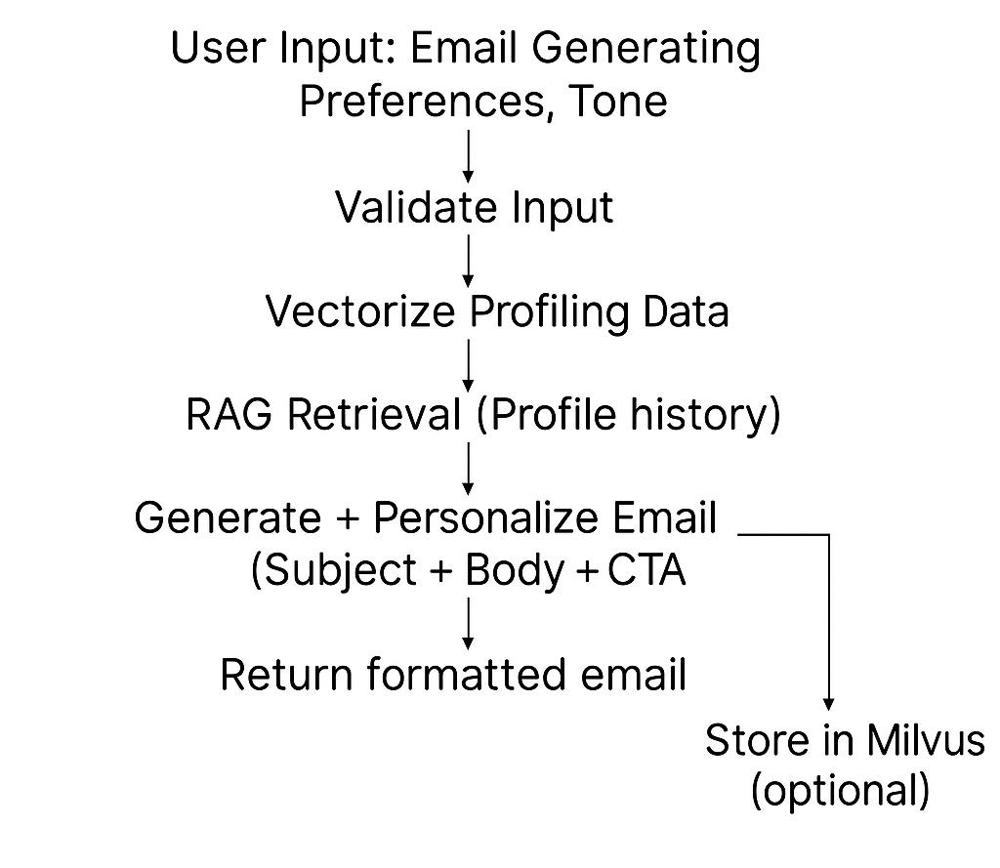

5.2 Document Upload Workflow

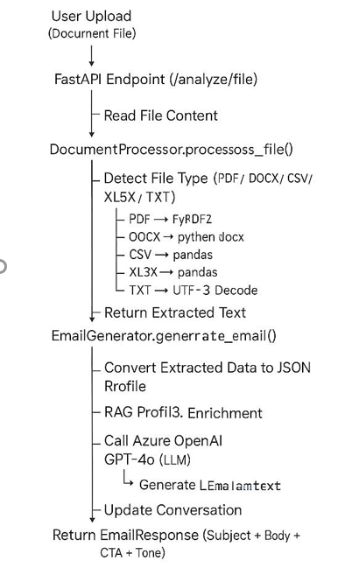

5.3 Chat Workflow

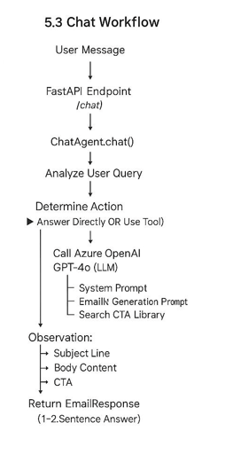

5.4 Bulk Email Workflow

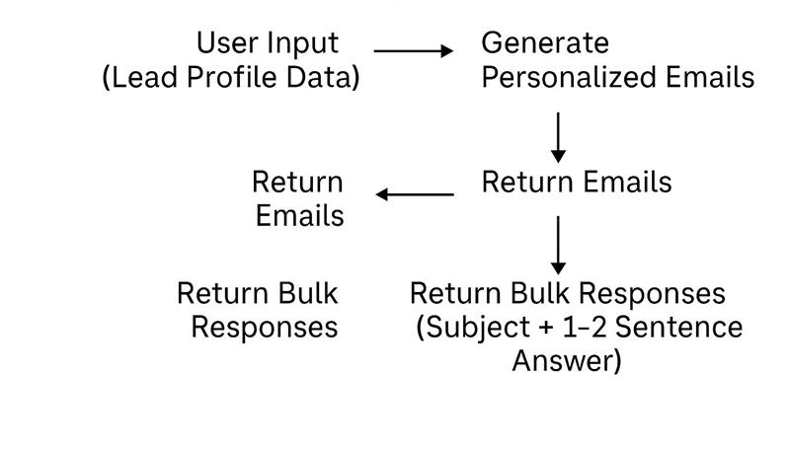

6. Deployment Guide

6.1 Prerequisites

**System Requirements**:
- Python 3.12 or higher
- 4GB RAM minimum (8GB recommended)
- 2GB disk space
**External Services**:
- Azure OpenAI account with:
- GPT-4o deployment
- text-embedding-3-small deployment
- Milvus/zilliz Cloud account (optional, for vector storage)

6.2 Environment Setup

6.2.1 Clone Repository

git clone <repository-url>
cd Capstone-

6.2.2 Create Virtual Environment

python -m venv .venv
# Windows
.venv\Scripts\activate

6.2.3 Install Dependencies

pip install -r requirements.txt

6.2.4 Configure Environment Variables
add pinecone configuration ##
Create config/.env file:
# Azure OpenAI Configuration
AZURE_OPENAI_ENDPOINT=https://your-resource.openai.azure.com/
AZURE_OPENAI_API_KEY=your-api-key-here
AZURE_OPENAI_API_VERSION=2024-05-01-preview
AZURE_OPENAI_DEPLOYMENT_NAME=gpt-4o
AZURE_OPENAI_EMBEDDING_DEPLOYMENT=text-embedding-3-small
# Milvus Configuration (Optional)
MILVUS_HOST=your-milvus-host.cloud.zilliz.com
MILVUS_PORT=443
MILVUS_USER=your-username
MILVUS_PASSWORD=your-password
MILVUS_SECURE=true
MILVUS_COLLECTION_NAME=sales_transcripts

6.3 Running the Application

6.3.1 Development Mode

python run_api.py
Server starts at: http://localhost:8000

6.3.2 Production Mode

uvicorn src.api.main:app --host 0.0.0.0 --port 8000 --workers

6.4 Configuration Management

6.4.1 Configuration Files

**config/config.yaml**:
- Azure OpenAI settings
- Milvus database settings
- FastAPI configuration
- Analysis configuration
- Logging configuration
**config/prompts.yaml**:
- System prompts
- Analysis prompts
- Sales helper prompts
- Chat agent prompts

6.4.2 Logging Configuration

**Log Levels**: DEBUG, INFO, WARNING, ERROR, CRITICAL
**Log File**: logs/app.log
- Max Size: 10 MB
- Backup Count: 5 (rotation)
**Console Logging**: Enabled with color coding

6.5 Database Setup
##pinecone

6.5.1 Milvus Cloud Setup

- Create account at https://cloud.zilliz.com/
- Create new cluster
- Create collection (category 0, category 1, promotional, data)
- Create partition(input_mails, send_mails)
- Copy connection details to `.env`

6.5.2 Collection Schema

**Collection Name**: Configurable (default: )
**Fields**:
- `email_id`: VARCHAR (primary key)
- `embedding`: FLOAT_VECTOR (1536 dimensions)
- `transcript_text`: VARCHAR
- `analysis_result`: VARCHAR (JSON string)
- `source_type`: VARCHAR
- `timestamp`: INT64
- **Index**: IVF_FLAT with L2 metric

6.6 Monitoring & Maintenance

6.6.1 Health Checks

curl http://localhost:8000/health

6.6.2 Log Monitoring

tail -f logs/app.log

6.6.3 Performance Metrics

**Key Metrics to Monitor**:
- API response times
- Azure OpenAI API latency
- Milvus query performance
- Memory usage
- Error rates
**Recommended Tools**:
- Prometheus + Grafana
- Azure Application Insights
- ELK Stack (Elasticsearch, Logstash, Kibana)

Backup & Recovery
  - ##add pinecone back up and recovery

6.7.1 Milvus Backup

- Use Milvus backup utilities
- Schedule regular backups
- Store backups in cloud storage (Azure Blob, AWS S3)

6.7.2 Configuration Backup

- Version control for config files (excluding `.env`)
- Secure storage for `.env` file

7. Business Documentation

7.1 Use Cases

7.1.1 Personalized Email Generation
Actor: HR/Marketing Team
Goal: Generate birthday, anniversary, and approval emails using profile data.
Flow:
User uploads profile or enters details
Selects email type
System enriches profile using RAG
LLM generates subject + body + CTA
User views/downloads/sends email
Success:
- <10 sec generation
- Personalization accuracy >90%

7.2 Business Logic & Rules

7.2.1 Priority
High: Today’s birthday/anniversary, urgent approvals
Medium: Occasions in next 7 days
Low: General announcements

7.2.2 Tone Rules
- Friendly: Birthday, Anniversary
- Professional: Announcements
- Formal: Approvals, HR notices

7.2.3 CTA Rules
Birthday: “Share your celebration moments!”
Anniversary: “Share your milestone!”
Approvals: “Please proceed as instructed.”
Festival: “Join the celebration!”

7.3 Success Criteria & Acceptance Requirements
Functional Requirements
✔ Accept profile/manual input
✔ Generate personalized emails
✔ Tone customization
✔ CTA generation
✔ Bulk generation support
✔ Milvus vector storage
✔ Chat assistant
✔ Semantic search
✔ Support CSV/XLSX/DOCX/PDF
Non-Functional Requirements
✔ <10 sec single email generation
✔ <30 sec bulk generation
✔ Support files up to 25MB
✔ 99% uptime
✔ HTTPS security
✔ Scalable to thousands of users
Acceptance Criteria
Accuracy:
- Personalization >90%
- CTA relevance >85%
- Tone accuracy >95%
Performance:
- Email generation <8 sec
- Chat <5 sec
- Search <2 sec
Usability:
- Simple UI
- One-click generation
- Easy file upload
- Clean chat panel

7.4 Workflow Documentation

7.4.1 Email Analysis Workflow
Step 1: Upload Prospects
- Admin uploads prospect list
- Data stored in prospect DB
Step 2: RAG Enrichment
- Fetches latest info
- Retrieves past interaction history.
Step 3: Email Personalization
- LLM generates:
- Subject line
- Body content
- CTA
- Tone (Formal/Friendly)

Step 4: Response

8. Technical Specifications

8.1 Dependencies
# add version
Core Framework

- FastAPI==
- uvicorn[standard]==
- pydantic==

AI/ML

- llm==
- langchain==
- langchain-community==
- langchain-core==
- langchain-text-splitters==

Database

- Pinecone

Utilities

- pyyaml==
- python-dotenv==
- colorlog==
- requests==

8.2 API Rate Limits (Azure OpenAI)

GPT-4o

- Tokens per minute: (varies by subscription)
- Requests per minute:
Embeddings
- Tokens per minute:
- Requests per minute:

8.3 Security Considerations

Current Implementation

- Environment variable-based configuration
- CORS enabled (all origins - development only)
- No authentication/authorization

Production Recommendations

- Implement API key authentication
- Restrict CORS to specific origins
- Use HTTPS only
- Implement rate limiting
- Add input validation and sanitization
- Encrypt sensitive data
- Regular security audits
- Implement logging and monitoring

9. Troubleshooting

9.1 Analysis

Issues | Resolution
Milvus connection failed | Check network and credentials
Emails not sending | Validate SMTP API key
RAG results empty | Check data sources & crawling permissions
GPT error | Check Azure credits and rate limits

9.2 Debug Mode

Enable debug logging in config/config.yaml:
logging:
level: "DEBUG"

10. Advantages
- Highly personalized emails
- Automated compliance
- Automatic segmentation
- Scalable to millions of users

11. Limitations
- RAG depends on data availability
- Requires stable email service provider
- LLM costs increase with scale.
- Database cost
12. Future enhancement
- The system can be extended with several enhancements:
- Multi-Lingual Email Personalization
- Support for Multi-Channel Communication
- AI-Powered Campaign Optimization
- Automated Template Generation
- Dynamic Sender Identity
- Integration with CRM
- Auto-Response Agent
- Login system(google log, IMAP4)

13. Conclusion
This project successfully demonstrates an end-to-end automated AI-powered email personalization system. By using profile analysis, RAG-based context enrichment, and LLM-driven content generation, the system significantly improves email campaign performance and reduces manual effort. This solution aligns with industry best practices for marketing automation and demonstrates practical use of modern AI techniques.

14. Version History

Version 1.0 – 2025-11-15

- Initial release
- Full RAG pipeline
- Profile analyser
- Email generator

